**UNLOCKING INSIGHTS INTO THE GLOBAL AIR TRANSPORTATION**

**NETWORK WITH TABLEAU**

**Project report**

**Team members**

B. Sindhu

A. Safiya Tabassum

V. Sevanthi

R. Senka

1. INTRODUCTION
   1. Overview

Air transportation is the transportation of passengers and goods via aircrafts.

The global air transportation market is expected to witness significant growth in the

Increasing air passenger traffic, growing number of airport expansion projects, and

rising demand for air freight services. Air transportation was nationalized in 1953.

Alliance air, Indian airlines, private scheduled airlines, and non-scheduled operators

Provide domestic air services. I analysis the dataset in the paper.

* 1. Purpose

Air transportation plays a critical role in connecting people and businesses around

the world, providing faster and more efficient transportation options than other modes

of transportation.

1. Problem Definition & Design Thinking
   1. Empathy Map 
   2. Ideation & Brainstorming Map



1. Result

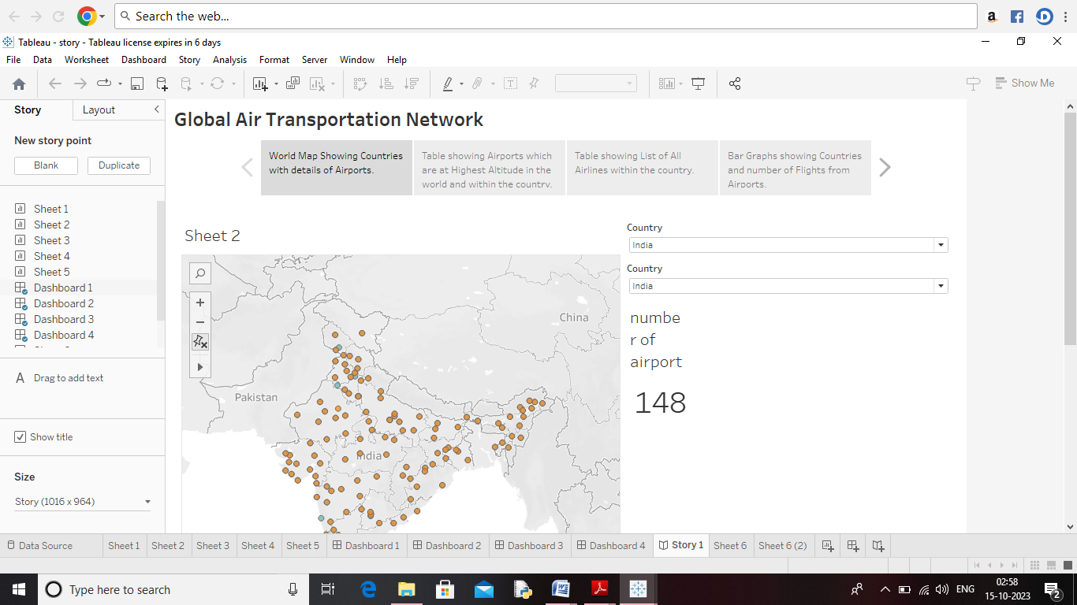

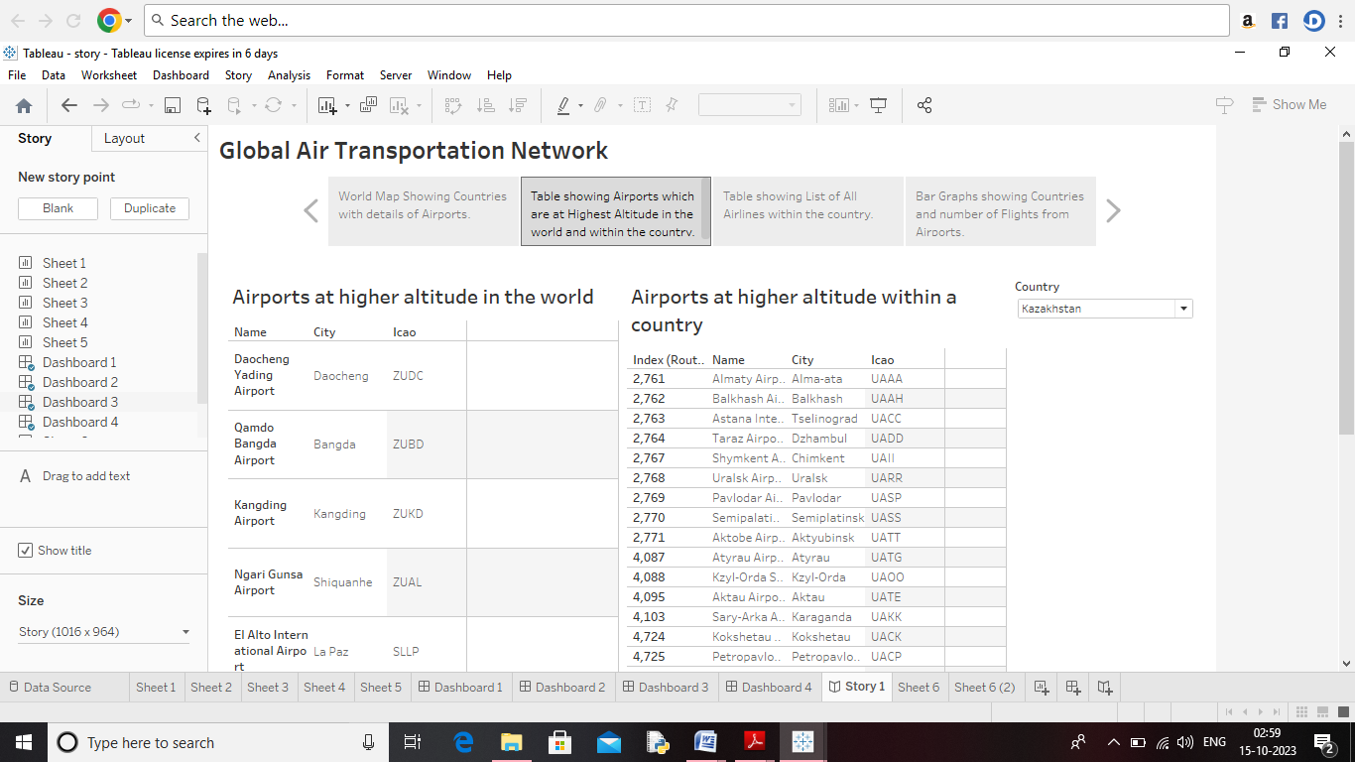

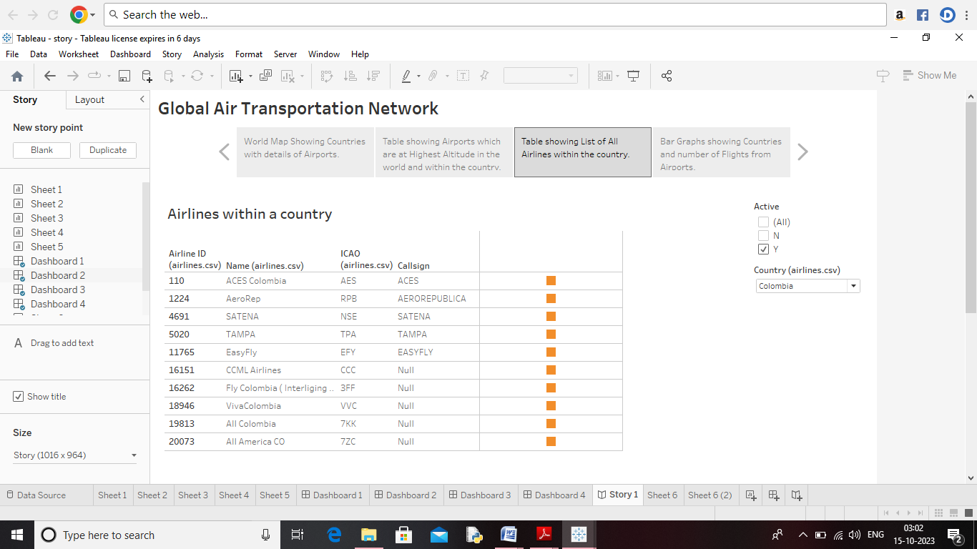

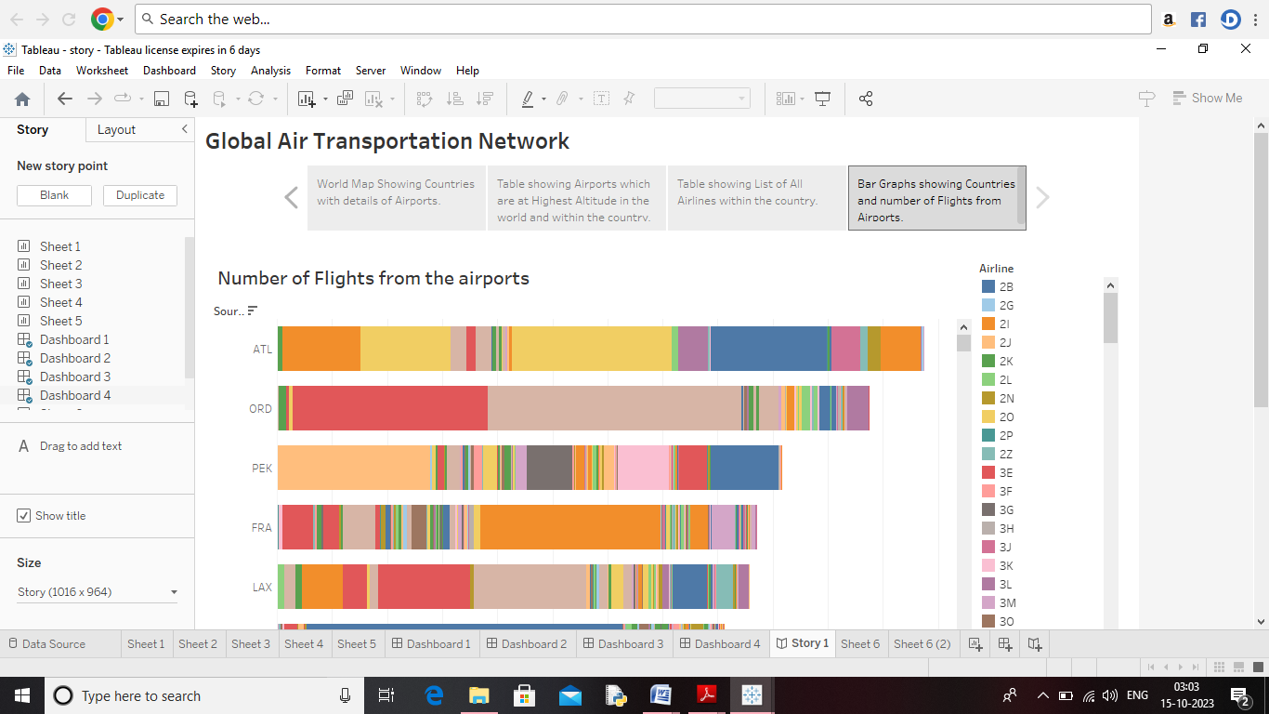

1. **ADVANTAGES & DISADVANTAGES**

Advantages:

Fast delivery times undoubtedly, one of the most advantageous features

Offered by air transport is its speedy delivery times. There is no faster transport service

than air transport. In addition, the frequency of flights makes delivery times very frequent

and fast.

High standard of protection with a low rick of robbery and injury. Tightly

Controlled airport controls also minimise cargo theft and loss

Disadvantages:

Limited cargo capacity: while air transport is incredibly fast, it has limitations

in terms of cargo volume. Cargo planes have limited space compared to ships, making them less suitable for transporting large quantities of goods.

Air transport can involve higher costs than other options, and in not suitable for

all goods. Flights are subject to delay or cancellation. You will need to pay taxes at each

airports you use.

1. **APPLICATIONS**

Modeling air transport networks aims airline companies to organize their routes in

a cost-efficient way and therefore maximize their profits. Air transport network investigate system robustness.

1. **CONCLUSION**

The air transport industry is not only a vital engine of global socio-economic

Growth but is also of vital importance as a catalyst for economic development in most

Countries and for many regions within each country. Its importance arises not only from

its ability to facilitate the movement of people but also its ability to expedite the

movement of goods.

1. **FUTURE SCOPE**

The most recent estimates suggest that demand for air transport will increase

by an average of 4.3% per annum over the next 20 years.